2004 May
Nuclear Reaction Data Center Meeting
Brookhaven National Laboratory

Participants
CHINA: Yu Hongwei
HUNGARY: Ferenc Tárkányi, Sándor Takács
JAPAN: Akira Ohnishi, Naohiko Otsuka
RUSSIA: Svetlana Babykina, Anatoly Blokhin, Sophiya Taova, Vladimir Varlamov
UKRAINE: Olena Gritzay, Oleksandr Kaltchenko
UNITED STATES OF AMERICA: Victoria McLane, Pavel Obložinský. Observers: Boris Pritychenko, David Winchell, Charles Dunford
OECD Nuclear ENERGY Agency: Hans Henriksson, Claes Nordborg.
IAEA: Alan Nichols, Otto Schwerer
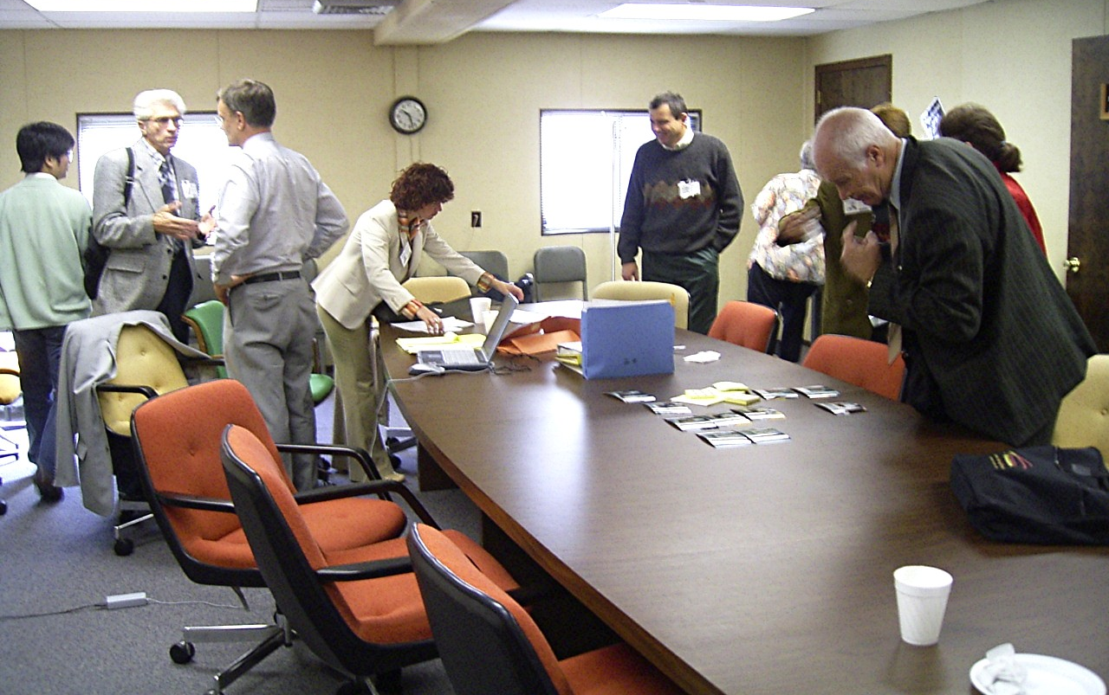
Akira Ohnishi, Vladimir, Otto, Sophie, Sándor, Oleksandr Kaltchenko

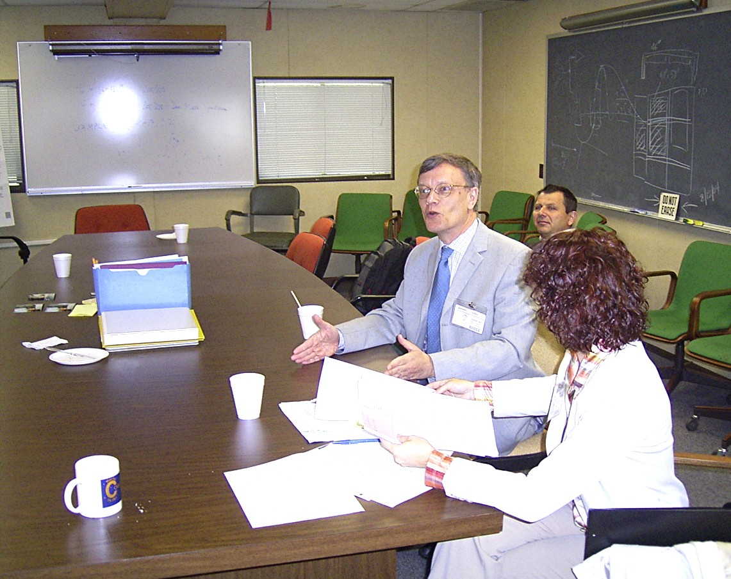

Otto, Sándor, Sophie

Party at Vicki & Peter’s
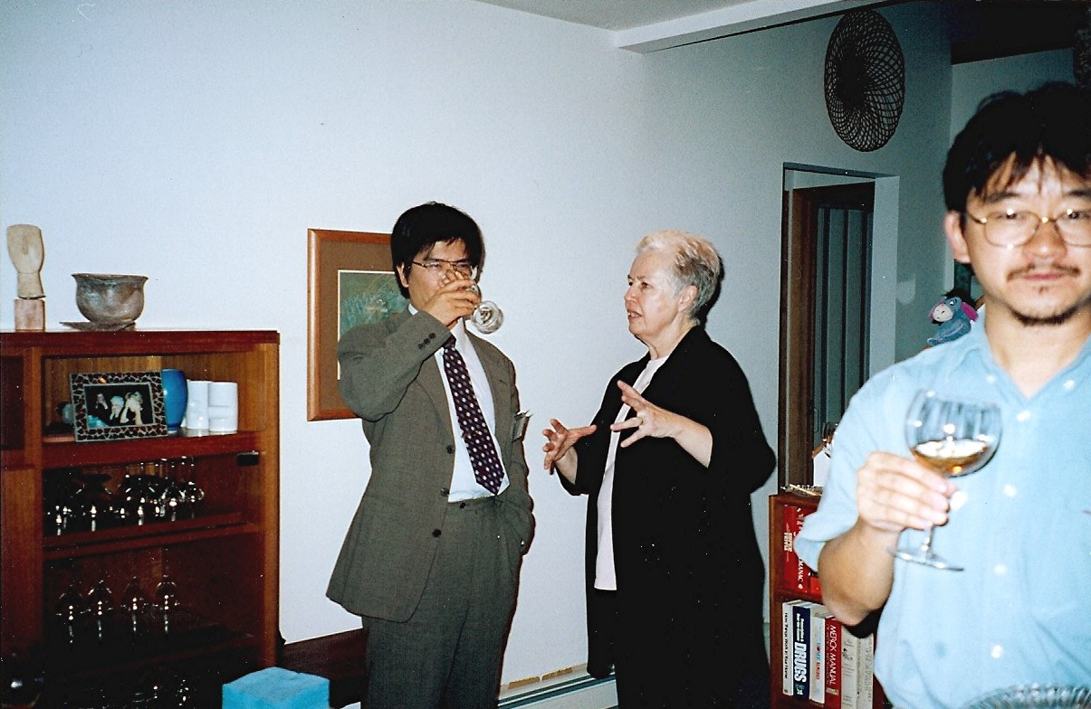
Akira Ohnishi, Vicki, Naohiko

